**FPT ACADMY INTERNATION**

FPT-APTECH

--o0o--

fpt

**Project Report**

Patient Info System

Students’ name (code on eProject Guide):

1. **Dương Văn Tùng**
2. **Đỗ Duy Tùng**
3. **Nguyễn Văn Hinh**
4. **Nguyễ Văn Thiên**
5. Problem Definition

‘SANJEEVANI’ is a hospital providing the general health services. The

information about the patients admitted in the hospital is maintained properly yet

such information is not always easily accessible.

There is growing realization that the more widespread use of information

technology to increase efficiency and enable changes in health care delivery

processes could do much to improve the performance of the health care system,

within the bounds of appropriate measures to protect the confidentiality of private

health information. Hence the higher authorities of hospital have decided to for

a computer based patient record system includes all the elements that facilitate

the capture, storage, processing, communication, security, and presentation of

computer-based patient record information.

1. Customer Requirement Specification

Requirement Summary

Depending on the decision given by the management on the Computer Based

Patient Information system is to be developed. Following are the requirements

based on which the system needs to be developed.

1. The system will support registering patients

2. Users of this system can search for patients by name, admission date,

discharge date etc.

3. Users can view the previous visit histories of any patient.

4. System can maintain the list of doctors in the hospital.

5. System can maintain the list of beds/rooms available in the hospital.

6. Patients are categorized into “In Patients” and “Out Patients”

7. Perform necessary validations.

1. Architecture and Design of the Project



Two-Tier Architecture of the Project

1. Data Flow Diagram

Login

Display form find data

Import fiels

Show message

Check data exist or not

False

True

Save to database

Add Patient/Docter/Employee

Show message

Save to database

Check data exist or not

Import fiels

Display form find data

Update Patient

Edit fields

Check data Validate and contrains

Show message

False

True

Update save to database

Search and View Patient

Choose Item want to search or view

Display form/ search view

Check exist and input is valiable

Show message

False

True

Save to database

1. Entity Relationship (ER) Diagram

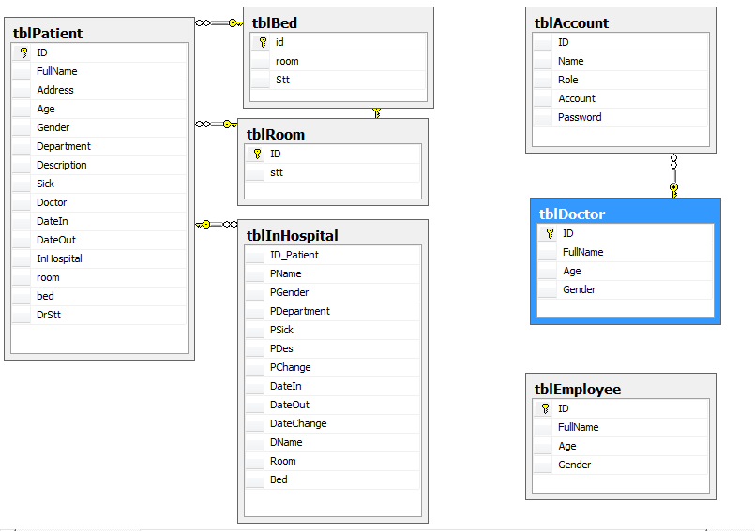

1. Database Design

|  |  |  |  |  |
| --- | --- | --- | --- | --- |
| ***Table: tblPatient*** | | | | |
| **Field Name** | **Data Type** | **Null** | **Key** | **Description** |
| ID | int | No | PK | Stores the id of the patient |
| FullName | nvarchar(300) | No |  | Stores the fullname of the patient |
| Address | nvarchar(300) | Yes |  | Stores the address of the patient |
| Age | int | Yes |  | Stores the age of the patient |
| Gender | varchar(6) | Yes |  | Stores the gender of the patient |
| Department | varchar(50) | Yes |  | Stores the department of the patient |
| Description | nvarchar(300) | Yes |  | Stores the description of the patient |
| Sick | nvarchar(300) | Yes |  | Stores the sick of the patient |
| Doctor | nvarchar(300) | Yes |  | Stores the doctor of the patient |
| DateIn | smalldatetime | Yes |  | Stores the date in of the patient |
| DateOut | smalldatetime | Yes |  | Stores the date out of the patient |
| InHospital | varchar(3) | Yes |  | Stores the status of the patient |
| room | int | Yes |  | Stores the room of the patient |
| bed | int | Yes |  | Stores the bed of the patient |
| DrStt | int | Yes |  | Stores the DrStt of the patient |

|  |  |  |  |  |
| --- | --- | --- | --- | --- |
| ***Table: tblBed*** | | | | |
| **Field Name** | **Data Type** | **Null** | **Key** | **Description** |
| id | int | No | PK | Stores the id of the bed in room |
| room | int | Yes |  | Stores the room of the hospital |
| Stt | varchar(5) | Yes |  | Store the Stt |

|  |  |  |  |  |
| --- | --- | --- | --- | --- |
| ***Table: tblRoom*** | | | | |
| **Field Name** | **Data Type** | **Null** | **Key** | **Description** |
| id | int | Yes | PK | Stores the id of the room in hospital |
| Stt | varchar(5) | Yes |  | Store the Stt |

|  |  |  |  |  |
| --- | --- | --- | --- | --- |
| ***Table: tblAccount*** | | | | |
| **Field Name** | **Data Type** | **Null** | **Key** | **Description** |
| ID | int | Yes |  | Stores the id |
| Name | nvarchar(300) | Yes |  | Stores the name |
| Role | varchar(25) | Yes |  | Stores the role |
| Account | varchar(12) | Yes |  | Stores the account |
| Password | varchar(50) | Yes |  | Stores the password |

|  |  |  |  |  |
| --- | --- | --- | --- | --- |
| ***Table: tblDortor*** | | | | |
| **Field Name** | **Data Type** | **Null** | **Key** | **Description** |
| ID | int | No | PK | Stores the id of the doctor |
| FullName | nvarchar(300) | No |  | Stores the name of the doctor |
| Age | int | Yes |  | Stores the age of the dortor |
| Gender | varchar(6) | Yes |  | Stores the Gender of the dortor |
| ***Table: tblEmployee*** | | | | |
| **Field Name** | **Data Type** | **Null** | **Key** | **Description** |
| ID | int | No | PK | Stores the id of the employee |
| FullName | nvarchar(300) | No |  | Stores the name of the employee |
| Age | int | Yes |  | Stores the age of the employee |
| Gender | varchar(6) | Yes |  | Stores the Gender of the employee |

|  |  |  |  |  |
| --- | --- | --- | --- | --- |
| ***Table:tblInHospital*** | | | | |
| **Field Name** | **Data Type** | **Null** | **Key** | **Description** |
| ID_Patient | int | Yes |  | Stores the id of the patient in Hospital |
| PName | nvarchar(300) | Yes |  | Stores the name of the patient in hospital |
| PGender | nvarchar(6) | Yes |  | Stores the gender of the patient in hospital |
| PDepartment | nvarchar(50) | Yes |  | Stores the department of the patient in hospital |
| PSick | nvarchar(300) | Yes |  | Stores the sick of the patient in hospital |
| PDes | nvarchar(300) | Yes |  | Stores the des of the patient in hospital |
| PChange | nvarchar(300) | Yes |  | Stores the change of the patient in hospital |
| DateIn | smalldatetime | Yes |  | Stores the date inof the patient in hospital |
| DateOut | nvarchar(50) | Yes |  | Stores the date out of the patient in hospital |
| DateChange | smalldatetime | Yes |  | Stores the date change of the patient in hospital |
| DName | nvarchar(300) | Yes |  | Stores the name of the docter |
| Room | int | Yes |  | Stores the room of the patient in hospital |
| Bed | int | Yes |  | Stores the bed of the patient in hospital |

1. Functions

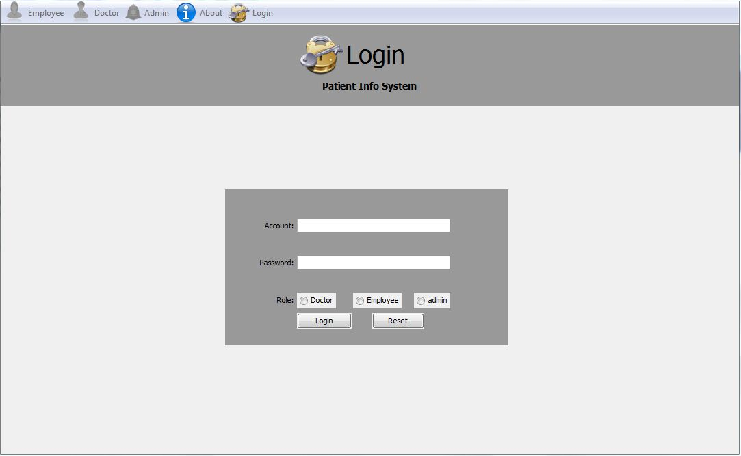

Login

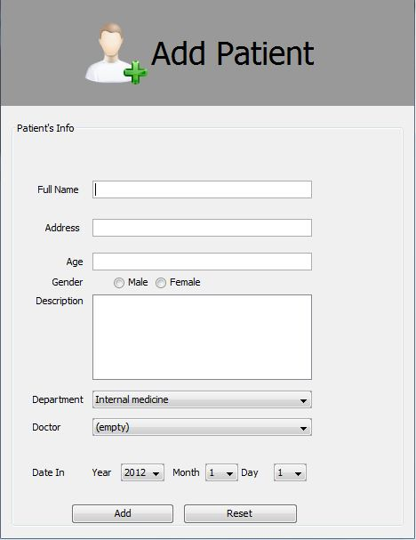

Add Patient

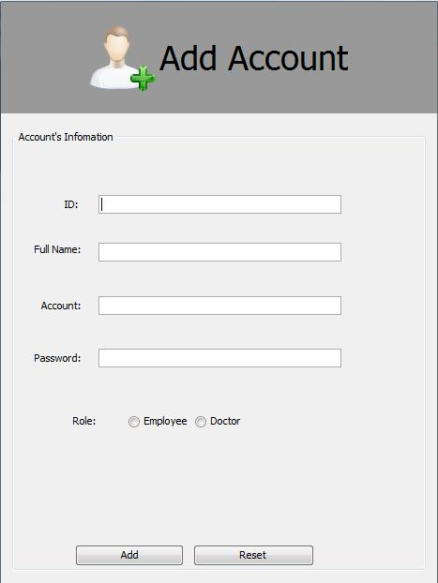

Add Account

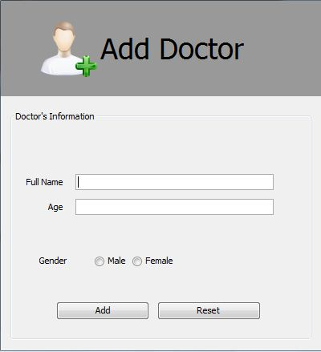

Add Docter

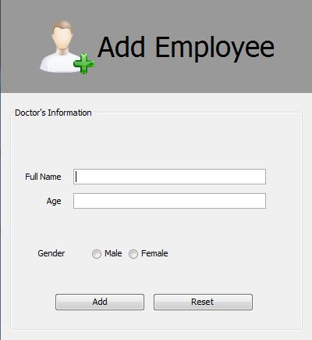

Add Employee

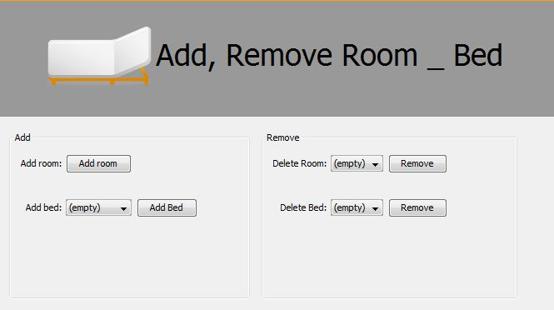

Add,Remove Room-Bed

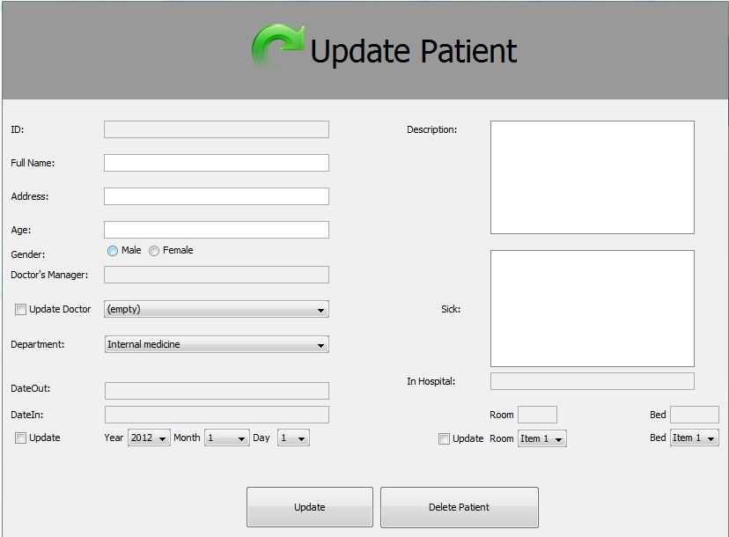

Update Patient

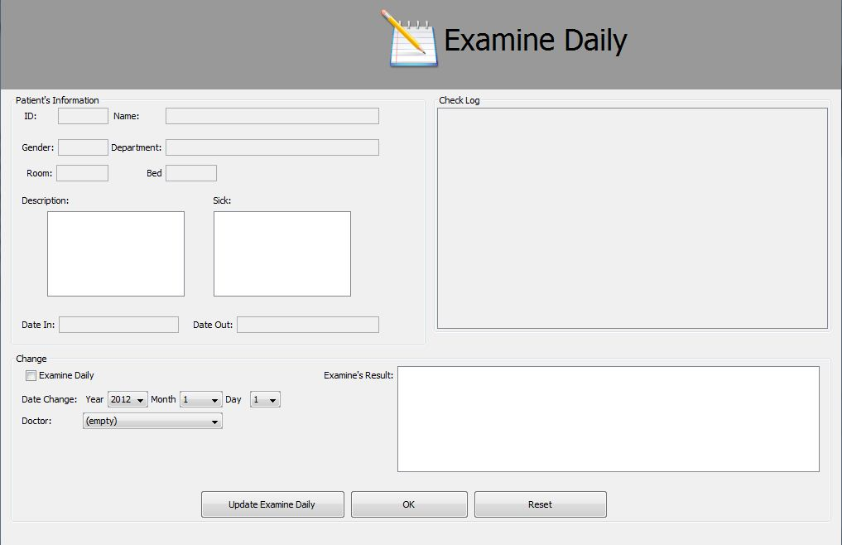

Examine Daily